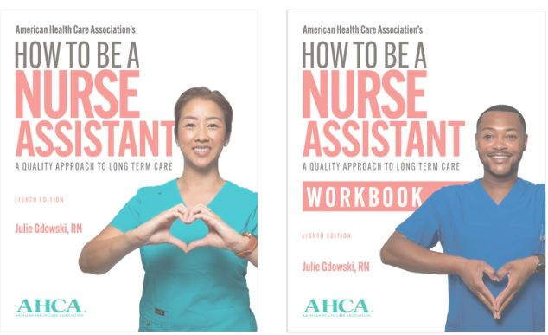

nEW! 8th Edition
How to be a Nurse Assistant

Order your copies now

- HTBinstructor.com Instructor Website Subscription $225.00 Non-Member: $255.00
- Printed Textbook $45.95 Non-Member: $59.95 (SAVE by ordering 10 or more)
- Printed Workbook $19.95 Non-Member: $23.95 (SAVE by ordering 10 or more)
- Training DVD $34.95 Non-Member: $39.95
- CNA Pin $4.50
- CNA Recognition Certificates $10.00 (pkg of 10)

Check out blended online training version at cnaonline.ahca.org

Order Form – Tax, shipping and handling will be added to Total
Item | Quantity | Total

Person Placing Order: _____________________________ Email address: ________________________________

Organization: _____________________________________________________

Mailing Address: _____________________________________________ City:________________ Zip:________
To order, choose one of the following options:
Email LuAnnSeverson@sdhca.org
Fax it to the SDHCA office at 605-339-1354
*other Certified Nurse Aide Training Program approved curricula can be viewed on the
SD Board of Nursing website

